Instructions:

You are assigned to a first-response task after a disaster occurred with a robot teammate.

You have access to the floor plan BEFORE the disaster but it may have changed due to damage incurred by the disaster. For example, some paths may be blocked and only your robot teammate that is working on the scene can sense these changes. So be aware.

In this scenario, your task is to team up with a remote robot that is working on the disaster scene. The team goal is to search all the marked locations AS FAST AS POSSIBLE and your role is to help the robot by providing high-level guidance about what the next marked location to visit.

To provide your high-level guidance to the robot, click on a room marked with  that is unvisited. This informs the robot that is the next room that you think it should visit.

Before each move, the system asks you a question regarding to the action robot about to perform:

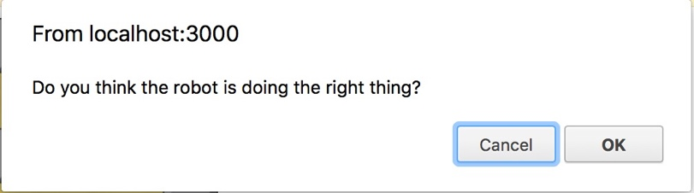

After you answered the question the robot will perform one action regardless of your answer. The system continues asking you questions until the robot gets to the ordered location.

You can change your command during the robot movement and order the robot to visit a different room if you think this is appropriate.

Your team performance is measured in virtue of time and how efficient you order the robot to move. If you give high level order to the robot, it will move 10% faster than its normal speed.

|  |  |
| --- | --- |
| Tile | Meaning |
| ../../../../Desktop/Screen%20Shot%202018-03-24%20at%202.17.06%2 | Breakable Obstacle |
| ../../../../Desktop/Screen%20Shot%202018-03-24%20at%202.21.23%2 | Needs Attention |
| ../../../../Desktop/Screen%20Shot%202018-03-24%20at%202.22.59%2 | Wall |
| ../../../../Desktop/Screen%20Shot%202018-03-24%20at%202.23.50%2 | Robot |

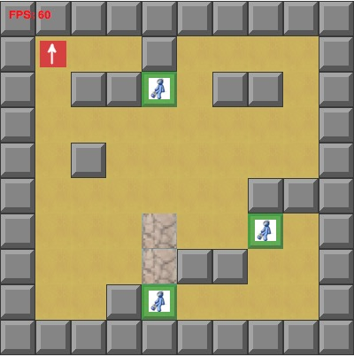

From the scale of 1 to 10, where 1 is the lowest and 10 is the highest, please answer the following questions:

1. How much did the robot contribute to team effectiveness in general?
2. How much did you contribute to team effectiveness in general?
3. How much do you like to collaborate with the robot again?
4. Write any comments about the robot

**Version 1: Your task is to suggest the robot the order of the rooms to be visited, so the robot can provide medical attention to the designated locations as fast as possible. Notice that the robot may or may not respond to your suggestion immediately.**

Questions:

1. Which room do you expect the robot to visit first? (answer in the form of room “location number” e.g. room 11)
2. What are the actions you expect from the robot to visit that room? (answer in the form of move “current location” “target location” e.g. move location 20 location 15)
3. After the robot visited the expected room, which room do you expect the robot to visit next?
4. What are the actions you expect from the robot to visit that room?
5. After the robot visited the expected room, which room do you expect the robot to visit next?
6. What are the actions you expect from the robot to visit that room?
7. After the robot visited the expected room, which room do you expect the robot to visit next?
8. What are the actions you expect from the robot to visit that room?